**ASSIGNMENT-8.3**

**Task Description#1  
Use AI to generate test cases for is_valid_email(email) and then implement the  
validator function.  
Requirements:  
• Must contain @ and . characters.  
• Must not start or end with special characters.  
• Should not allow multiple @**

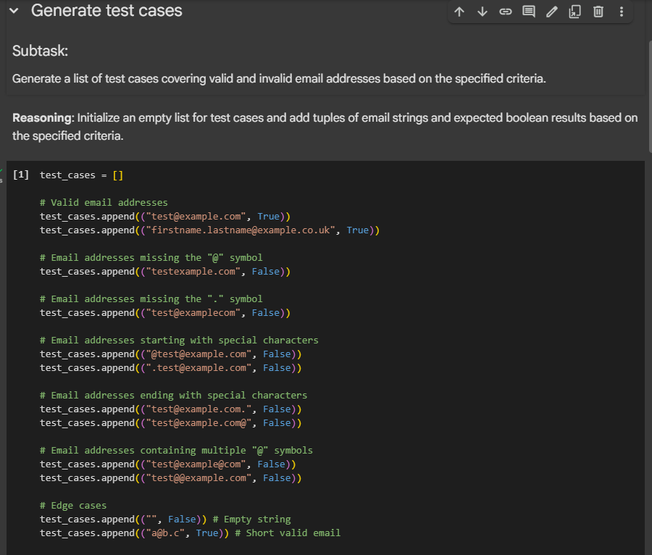

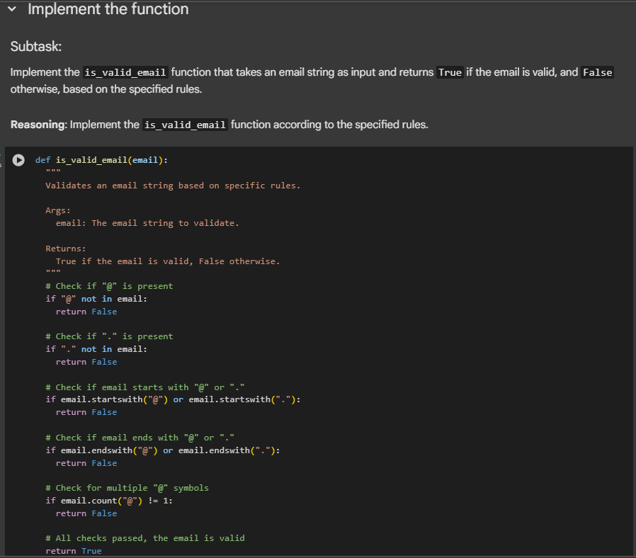

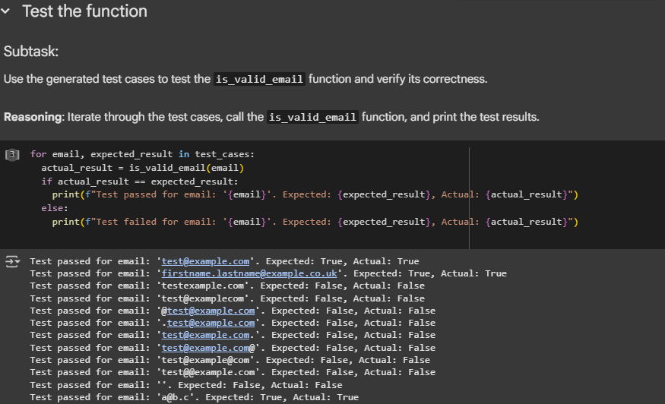

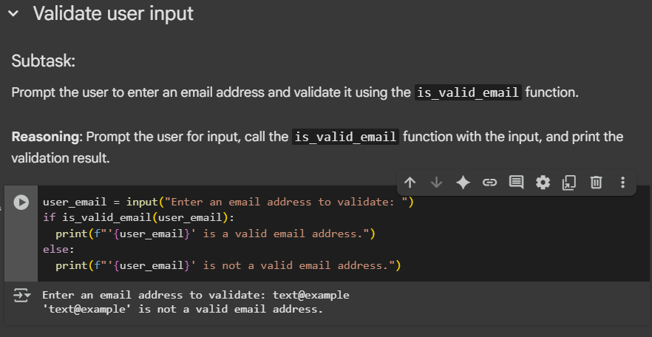

**Task Description#2 (Loops)  
• Ask AI to generate test cases for assign_grade(score) function. Handle boundary and  
invalid inputs.  
Requirements  
• AI should generate test cases for assign_grade(score) where: 90-100: A, 80-89: B, 70-  
79: C, 60-69: D, <60: F  
• Include boundary values and invalid inputs (e.g., -5, 105, "eighty")**

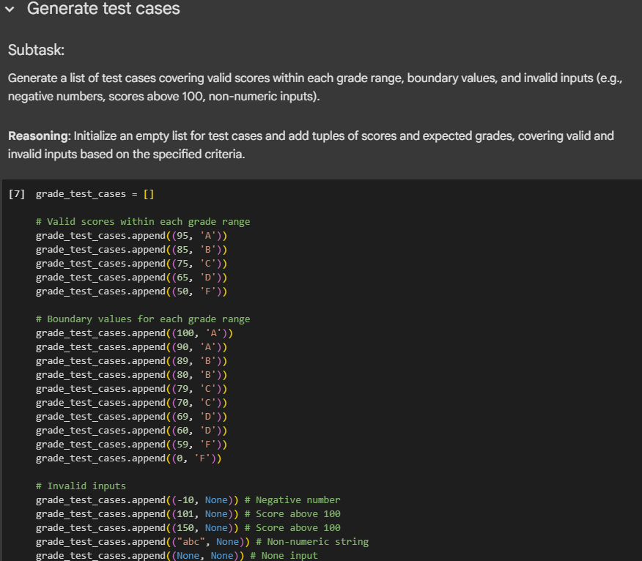

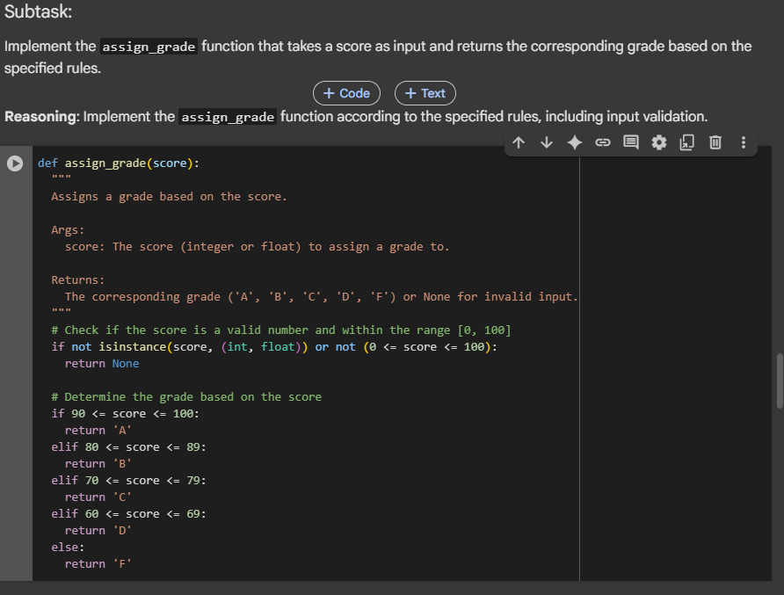

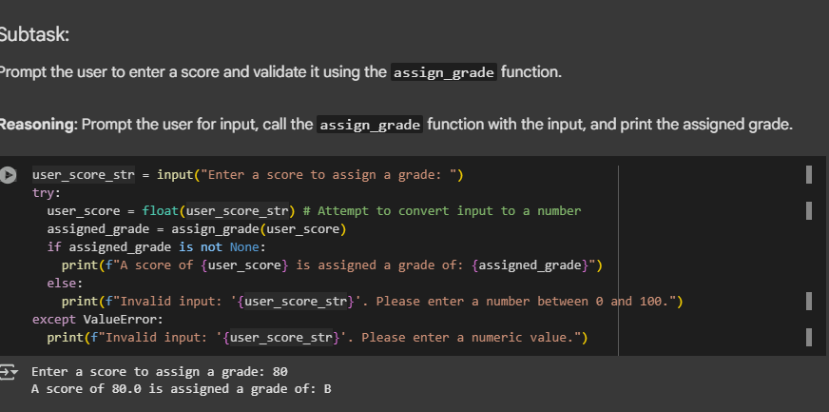

**Task Description#3  
• Generate test cases using AI for is_sentence_palindrome(sentence). Ignore case,  
punctuation, and spaces  
Requirement  
• Ask AI to create test cases for is_sentence_palindrome(sentence)  
(ignores case, spaces, and punctuation).  
• Example:  
"A man a plan a canal Panama" → True**

